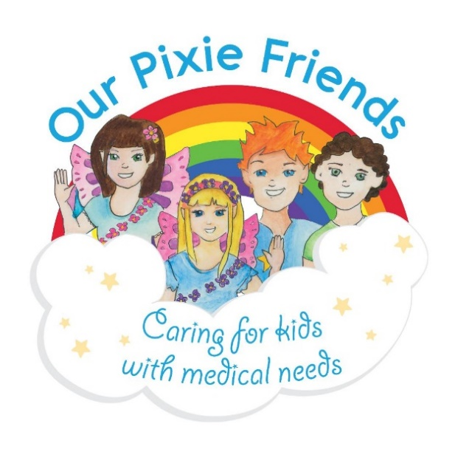

*Queen Pearl*

*King Jedrik*

*This certificate is awarded to ______________*

*for*

*_________________________*

*Well Done!*

**Bravery Award**