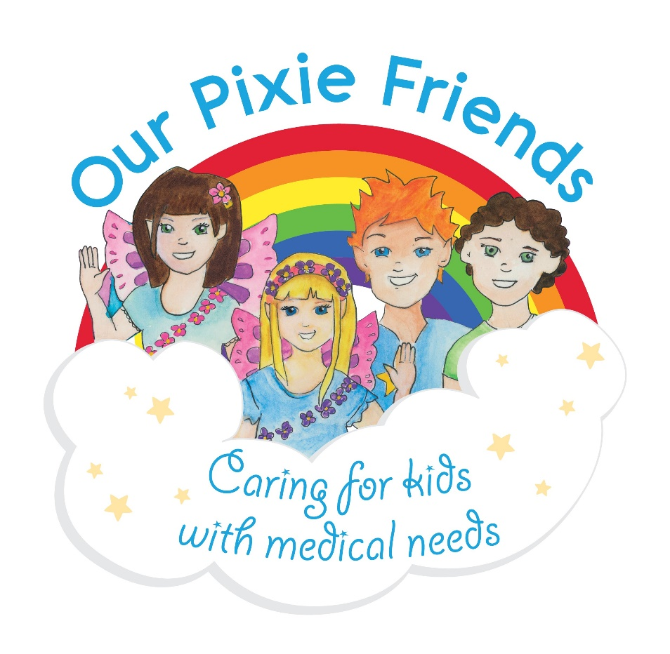
My name is ____________. I cannot eat ________________.

Our Pixie Friends would like you to help look after me
and keep me safe please.

