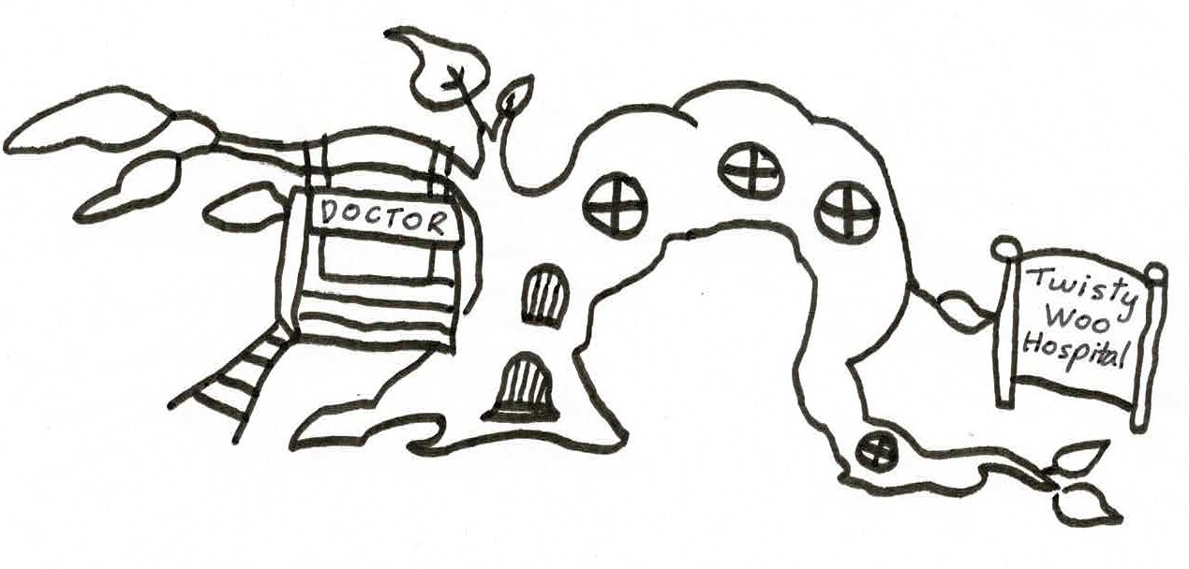
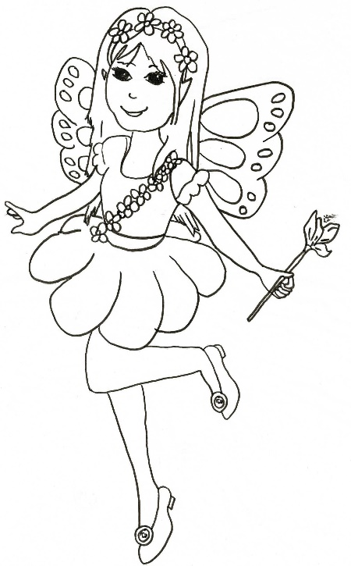
Sakaela says, “Get a teacher quickly if your friend is having trouble breathing.

