Listening Skills - Position words Level A
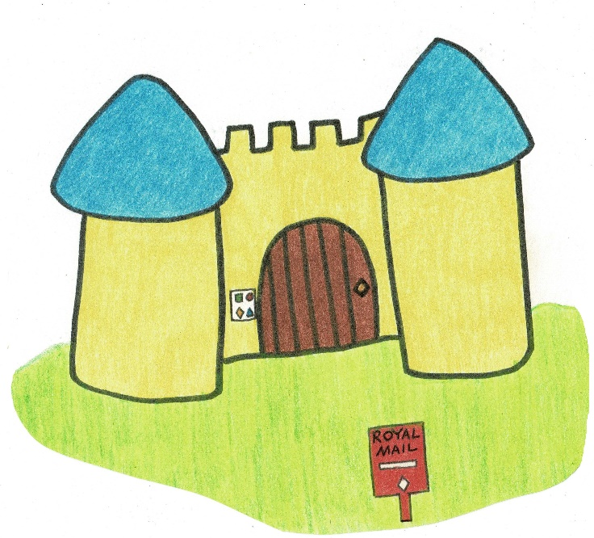

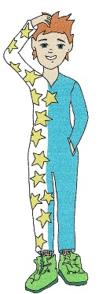
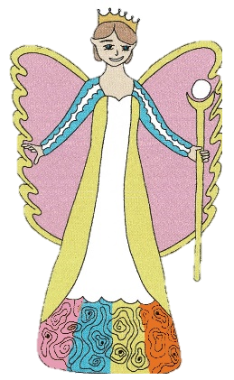
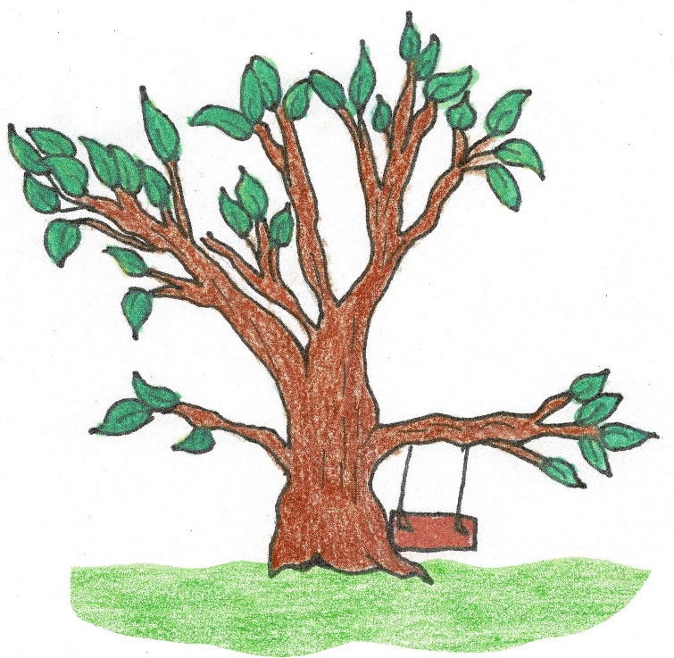

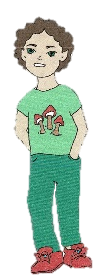
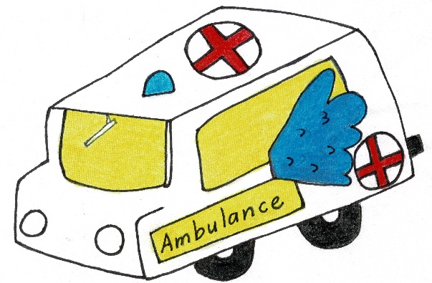

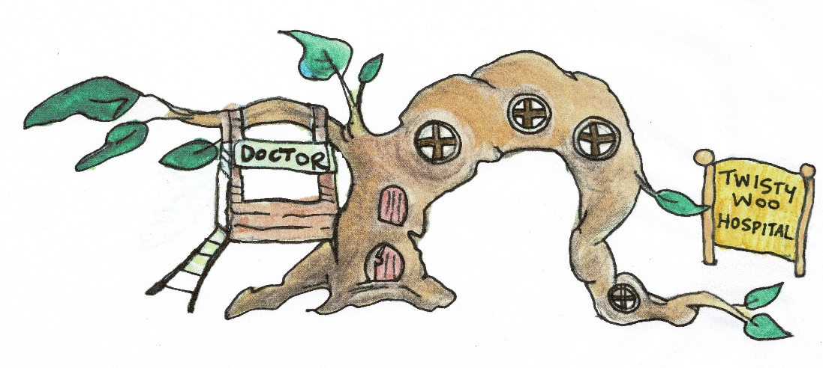

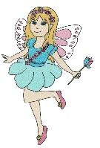

Listening Skills - Position words Level A
Instructions:
1. Write your name at the bottom of the page.
2. Draw yourself sitting on the swing.
3. Circle the small pixie in front of the tree.
4. Draw a ball beside that pixie.
5. Put a cross on the window in the hospital that is furthest to the right.
6. Colour the ambulance headlight on the left yellow.
7. Draw the sun in the top right corner of the picture.
8. Draw a bird between the castle and the sun.
9. Draw a stone below the mailbox.
10. Circle the pixie near the Twisty Woo Hospital.

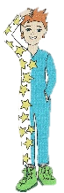
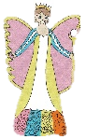
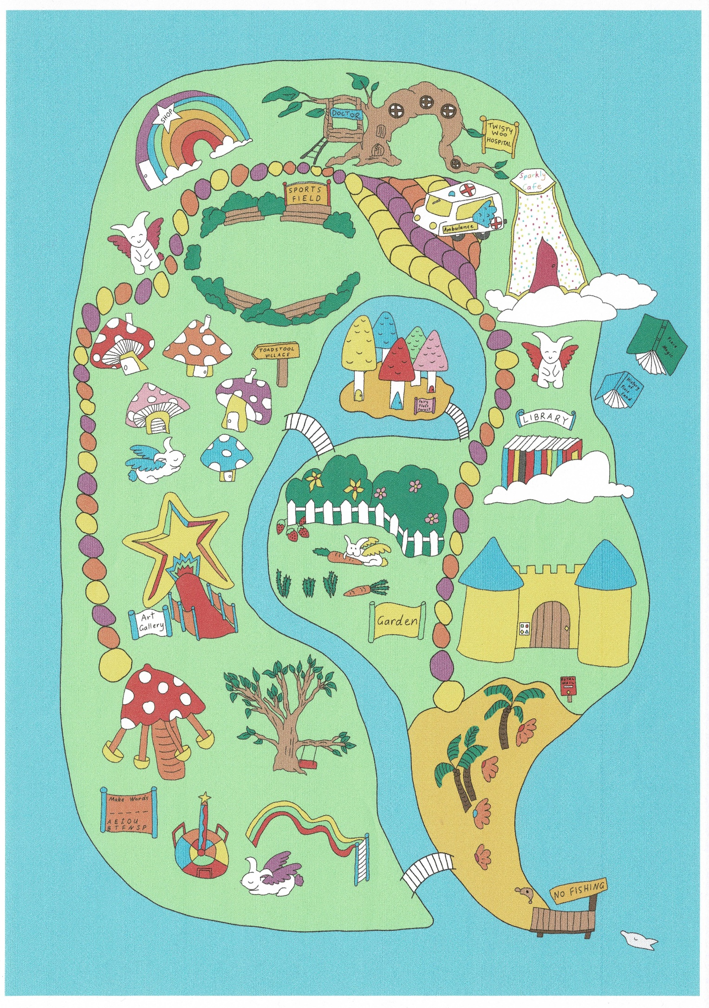
Listening Skills - Position words Level B
Listening Skills - Position words Level B
Instructions:
1. Write your name in one of the clouds.
2. Draw yourself inside the sports field.
3. Circle the flying bunny above the library and cross the one near the shop.
4. Draw a ball beside the pixie which is standing between the library and the castle.
5. Put a cross on the leaf on the hospital that is furthest to the left.
6. Circle the toadstool house which is furthest to the right.
7. Draw a big fish in the top right corner of the picture and a small fish in the bottom right corner below the jetty.
8. Draw a bird next to each shell at the beach.
9. Put a tick on every tree in the picture including the fairy floss trees.
10. Circle the bridge which is closest to the Twisty Woo Hospital.

