Literacy Games
Personal and Social Capability
In addition to developing early literacy skills, these games can assist with developing effective friendship skills as the children learn to accept others’ differences and help each other to achieve success. They learn to be good sports and accept that they do not always win.
Making Sentences Games
These game cards can be used for direct instruction or for free play time.
Cards can be enlarged onto A3 paper before laminating for class use. Attach magnets, velcro or blu-tac to the back so they can stick on a board.
Multiple copies can be made for small group or individual instruction. E.g. Make the sentence “We can see the library.” Or ‘Paizo went to the hospital with Zizzy.”
Children can play making sentences using the cards and trying to read their partner’s sentences.
Cards can be sorted into groups e.g. nouns, words beginning with ‘w’, pronouns, verbs, places – settings, characters.
Find the Word Games
Children race to be the first to find a particular word e.g. find ‘are’; find a word that starts with the /th/ sound; find a word that rhymes with ‘tan’; find a place that starts with the letter ‘h’. This can be played as a class in teams with large cards on the floor or stuck onto poles in the playground, in small groups or with individuals in need of some 1:1 assistance.
Variety can be achieved by playing with children sitting on both sides of a mat and the cards spread randomly on the floor. Two children only, one from each side of the mat, race to find the word and score a point for their team.
Another sight word practice variation has the class lined up in two teams. The teacher stands at the front and holds up a card. Only the first two people may say the word. The first child to give the correct answer scores the point for their team. The first team to score 5 or 10 points is the winner.

Our Pixie Friends Pty Ltd 2020
All illustrations are copyright. Teachers are granted permission to copy for class use only.
saw | was | and
on | the | the
in | The | a
under | a | were
saw | was | and
on | the | the
in | The | a
under | a | were

I | me | You
is | on | We
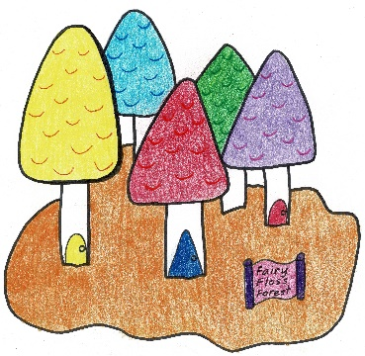 | 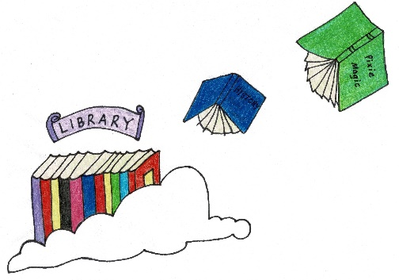 | 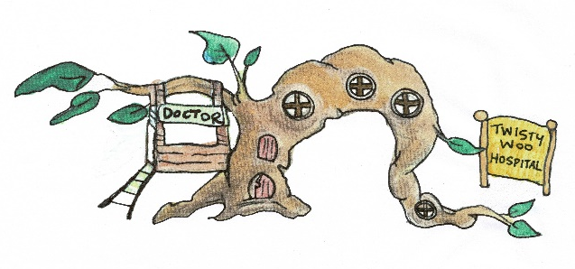

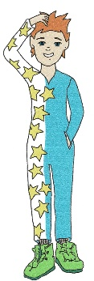  Paizo | 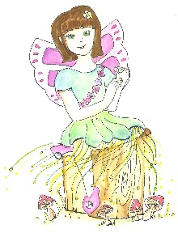  Zizzy | 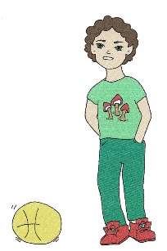  Minksy
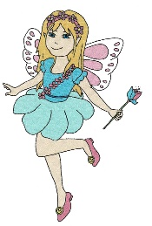  Sakaela | 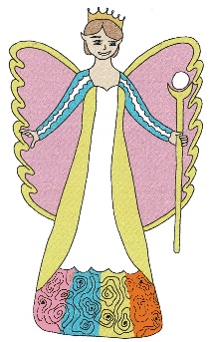  Queen Pearl | 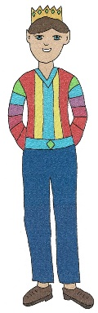  King Jedrik
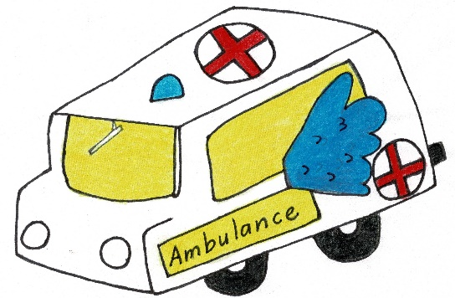 | 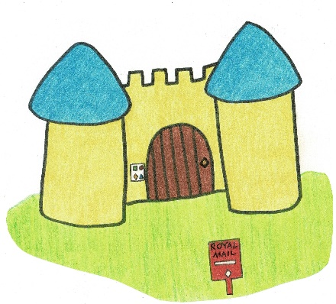 | 