**Minksy says, “If someone needs an ambulance, call**

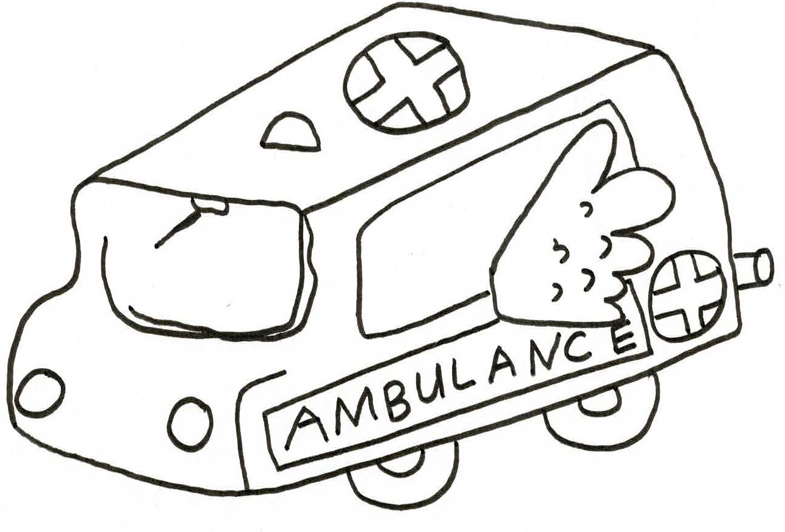**000.”**