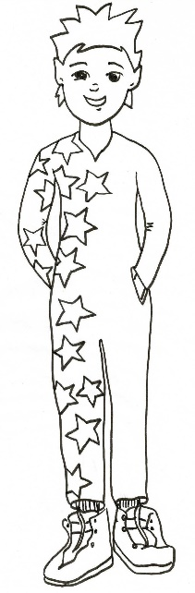
Paizo the Peanut Allergy Pixie says, “Always wash your hands well.”
Draw yourself and your friends washing your hands well.

