Cut out the pictures below and paste them next to the correct words. Then practise tracing the word ‘the’. Name:
the pixie
the tree
the bunny
the castle

The the the the
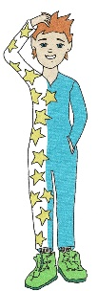 | 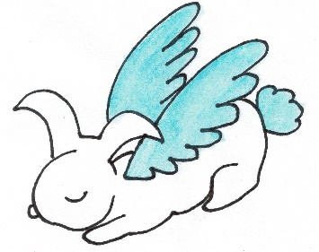 | 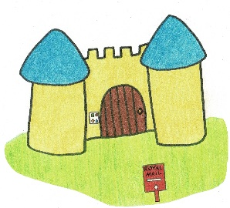 | 