Tens | Ones
1 | 0

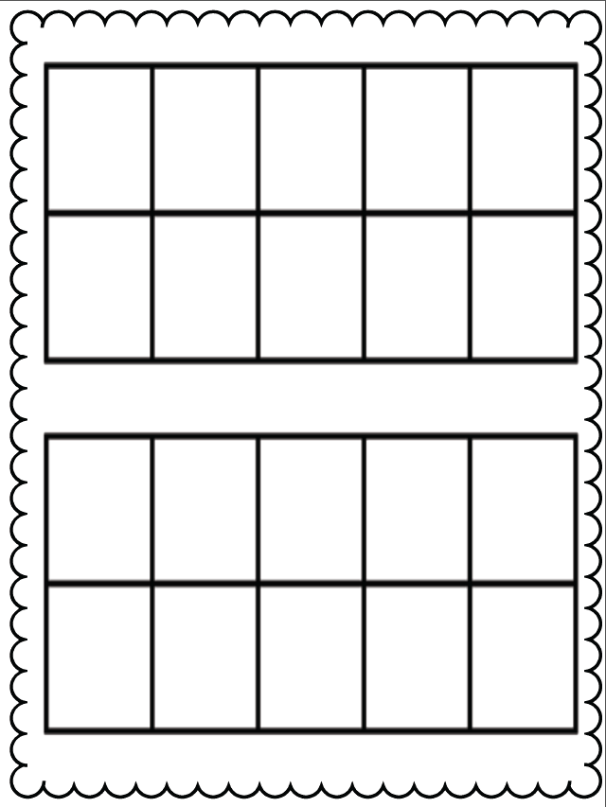
Tens | Ones
1 | 1

Tens | Ones
1 | 2

Tens | Ones
1 | 3

Tens | Ones
1 | 4

Tens | Ones
1 | 5

Tens | Ones
1 | 6

Tens | Ones
1 | 7
Tens | Ones
1 | 8
Tens | Ones
1 | 9

Tens | Ones
2 | 0

