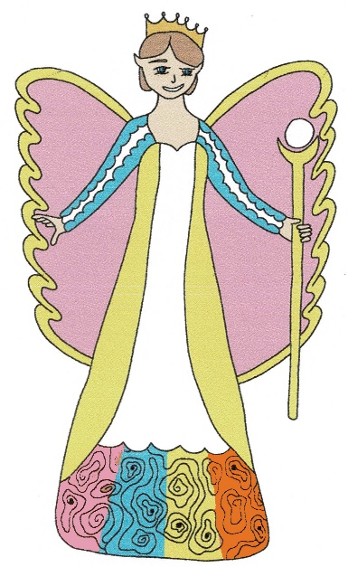
The Great Escape Game

Queen Pearl is searching for Sakaela to give her some medicine, but she is playing ‘Hide-and-Seek’ with the other Pixie Friends.
Choose a square for Sakaela to hide in. Maybe she is hiding in the castle or behind the tree in the playground. Mark it with a tiny dot while your opponent is not watching. Don’t let them see your page.
They have 4 turns at guessing your coordinates. If they catch you, they win, but if you escape, you are the winner.
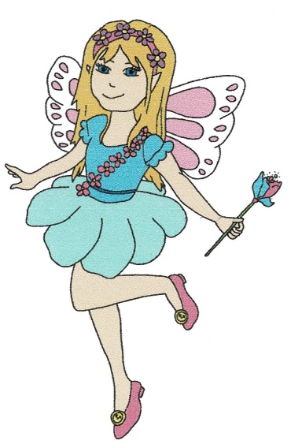
(You wouldn’t play ‘Hide-and-Seek’ if you needed medicine, would you? We know you would be very brave and just have it.)

12
11
10
9
8
7
6
5
4
3
2
1
 | A | B | C | D | E | F | G | H | I

