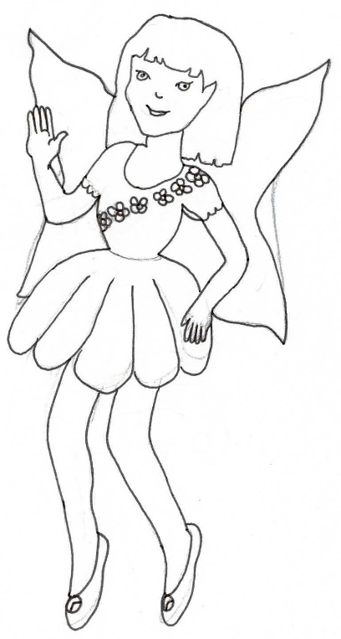
Pixies can be created and special messages written for any child’s needs.
Dear Teachers
If you have a child with special needs who you think would benefit from seeing a pixie who shares their medical condition, why not use the ‘Create your own Pixie Profile’ and send it to us at ourpixiefriends@gmail.com.
Please include in your email the special reason you wish that pixie to be included on the website so we can make sure that profile is uploaded as soon as possible. Please allow 7-10 days for us to check and upload it.
We can also create personalised letters from specific pixies to your class. Just email us with any special information about your children and we can respond. Why not have your class construct a letter to us after they have read or listened to a blog or story?
As we are particularly concerned with maintaining children’s safety online, we do ask that you do not provide any surnames, addresses or school details.
If you have any queries or feedback we would love to hear from you.
ourpixiefriends@gmail.com

