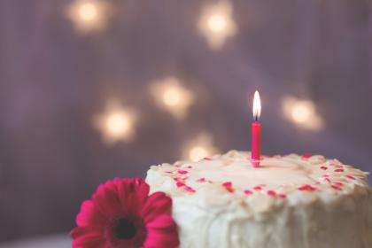
Birthday parties, Christmas, Halloween, barbecues, dinner parties, weddings … all these celebrations involve food. In every culture around the globe, food is a central component of social celebrations and something to look forward to … for most people. Not so for those of us with food allergies or parenting a child with food allergies.
Food Allergies Can Lead to Social Isolation

Is the food safe? Have they washed their hands? What are the chances of cross-contamination? Am I going to die? These are some of the questions going around in my head and my child’s head.
As a parent, I have 2 choices. To go or not to go….
If I choose to go, do I stress out trying to contact the host and organise which foods are and are not safe, or do I just bring all our own safe food? I always bring my daughter’s safe food wherever we go. It reduces stress for both of us as well as the host. It also increases her chances of being invited to the next event.
If I choose not to go, I wrestle with the guilt of making my child miss out on social activities, which leads to isolation for both of us – but at least she’s safe.
I was not prepared when my child came home sobbing her little heart out because she hadn’t been invited to a friend’s party only because she has allergies. The parent didn’t think the food would be safe and didn’t want to risk having her there. (Yes, that has happened.) Now I prepare myself for the heartache, because even though I know I would have supplied safe food, other people just don’t understand and don’t even think to consult me.
I try not to be too hard on them. In this era of the ’sue’ mentality, I can’t blame other parents for being afraid of something happening ‘on their watch’.
Whenever I take my daughter to a friend’s place or a party, I ensure I take the EpiPen trainer and give them a quick run-through of what to do in an emergency, as well as how to recognise the signs of anaphylaxis. I reassure them that if they are in doubt, administer the EpiPen, ring an ambulance then call me last. It’s okay. It’s better to do that than use a ‘wait and see’ approach. Not using it could be deadly.
Then I thank them for including my child in the festivities and reassure my daughter that she’ll have a great time and be okay if she only eats her safe food. Then I go and have a relaxing, stress-free couple of hours (haha) … keeping that phone close!

