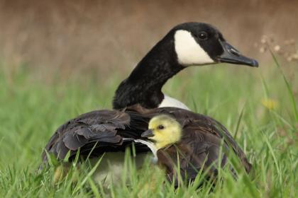
My Experience - Parenting a Child with Anxiety

Just in case you thought life didn't bring sufficient challenges, you are gifted with a child who suffers from anxiety....and now so do you. Worrying about your anxious child is par for the course.
That is my experience.
Over many years of trying to help my daughter with her anxiety, I have pieced together some of the best strategies we have found. Of course, this is not a definitive list and may or may not work for your family. If you do have concerns about your child’s anxiety, you should always seek advice from a medical professional.
These strategies have been pieced together from our many occupational therapist, psychologist and psychiatrist visits, so basically, for the cost of about 3 Lamborghinis!
We found some strategies worked, and some didn’t. Some worked for a little while and then had to be changed. From my experience, we did not find one thing that worked well every time, so I had to learn not to beat myself up when what I tried was unsuccessful. I just had to buckle up and prepare for the roller coaster of trial and error.
Here are a few things we tried that worked for a while:
1) The Sprizzletastic Dream Maker This is actually a hand pump decorated with her favourite characters. She would lie in bed listening to relaxation music and I would gently puff the Pixie Magic all down her arms and legs. It’s surprising how calm this would make her. Even my grandsons love doing this to relax. (These are available in the shop if you wish to purchase one.)
2) Worry Jar or Box – My child wrote or drew the things that were worrying her and placed them in a special box with a lid. The lid was crucial to prevent those worries escaping and bothering her during the day or night. We also tried writing them and ripping them up or having them mysteriously disappear during the day. Sometimes her favourite pixie came to take the worries away. Siobhan thought it was Paizo’s flying bunny, Fluffypan, who flew off and dumped the worries somewhere where they couldn’t ever be found. (Siobhan has written King Jedrik’s meditation for the story of this if you wish to listen to it.) The idea was that she would never have to worry about them as they were gone.
3) Monster Blaster Game: For a while, we had to go around the house after bath time or another suitable time before bed, pretending to blast the monsters, ghosts and other scary creatures to make sure the cupboard, under the bed and any dark corners were all clear before bedtime. We just had to be careful we didn’t do it for too long as it is amazing how little effort it takes to get her all hyped up again, then good luck getting the little blighter to bed at all!!!
4) Worry stone or pompom - Similar to a pet rock, the idea was that my child whispered (or shouted depending on her mood) her worries to the rock or soft pompom. Of course, it needed to have eyes, a face etc. It kept her worries all day so she could get on with enjoying Kindy, school or whatever she was doing, and the rock would look after the worries for her. This was great when she was very young, before she could write or speak well as the worry stone understood what she was telling it. After all, it was magic. If the rock was small enough, the teacher allowed her to keep it in her pocket during the day so she could whisper any new worries to it throughout the day. She found the pompom was much more comfortable in her pocket!
5) Worry Bunny or Pixie Friend This one was great for those bedtime worries. You know – those ones that come out just when you want to turn the lights out and go to sleep yourself?! Worry Bunny watched over her at night, kept away the baddies and monsters (or whatever was worrying her at the time) and guarded her while she slept.

See the other blog - Sensory Destressors for more strategies we have tried. I would love to hear your ideas too. Please email ourpixiefriends@gmail.com with your feedback and suggestions.

