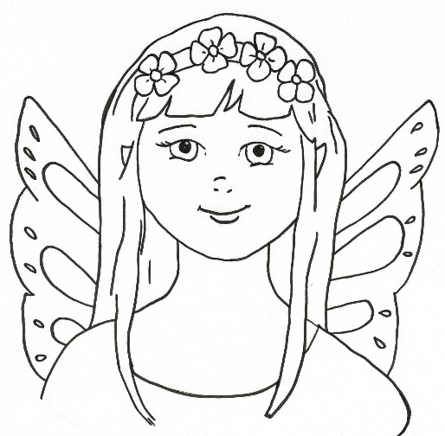
Sakaela says, “It’s okay to have allergies. I do too.”
Draw yourself having your antihistamine or nasal spray.

