What will you say if someone offers you food, but you do not know if it is safe for you?
Paizo says, “Draw yourself and write what you will say in the speech bubble. Then you can practise saying it, so you know what to do.”
Paizo | Me
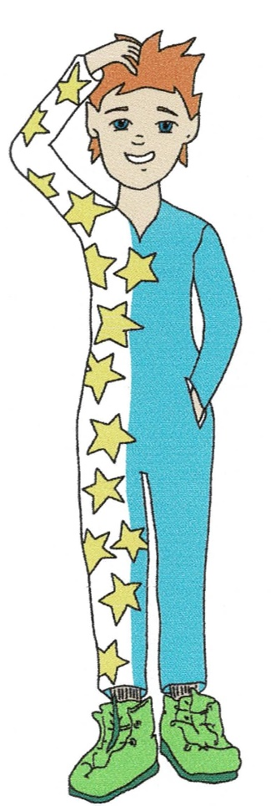

"No thank you. I have allergies. I can't eat it unless my Mummy or Daddy say it's safe for me."

