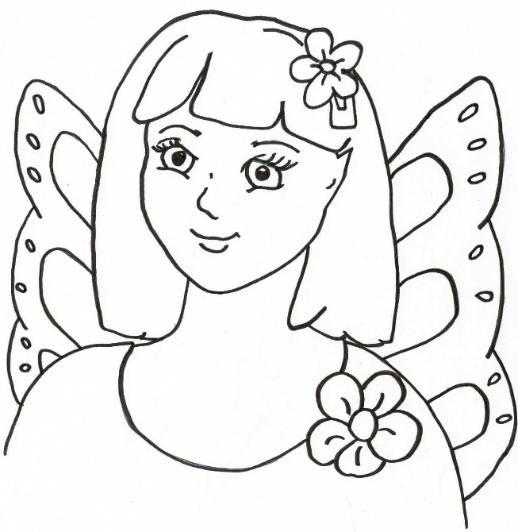
Zizzy says, “It’s okay to have asthma. I do too.”
Draw yourself having your puffer.

