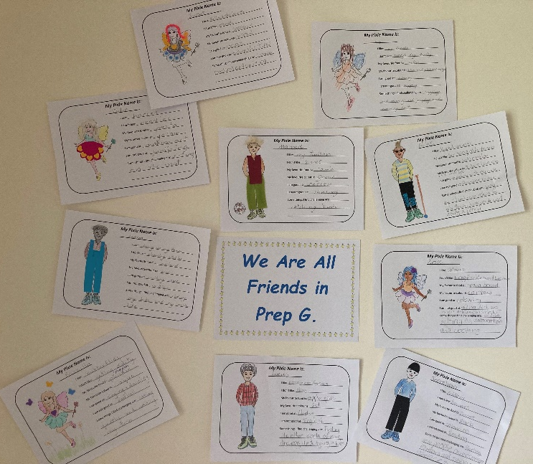
Building Self Esteem With Pixie Profiles in the Early Childhood Classroom

What a great activity to start the year with a buddy class. Thank you for this terrific photo. Making pixie profiles with an older buddy who can scribe for you while you create your own artwork is a wonderful way for children to get to know each other while developing oral language and social skills for both the younger and older students.
Self esteem is boosted as every child’s work is ‘good enough’ to be shared with the world in a safe online environment.
No last names or school information are published on the website. Teachers can relax, knowing that all content is checked and anything inappropriate will be altered or removed.
Teachers can send us a collection of photographs of children’s pixie profiles and we will ensure they are uploaded to the Magic Library on the website. If there are too many photos to send via email, just contact us and we will arrange for a folder on our Google Drive that you can easily upload all your files into in one easy step.
Children will receive a Thank You letter from King Jedrik and Queen Pearl and be notified when the work has been uploaded so they can experience the excitement of seeing their own creations online. What better way to encourage a love of learning!
If you want to send us more great classroom photos, need more information, or are unsure how to upload files, email us at ourpixiefriends@gmail.com. We can’t wait to hear from you!

