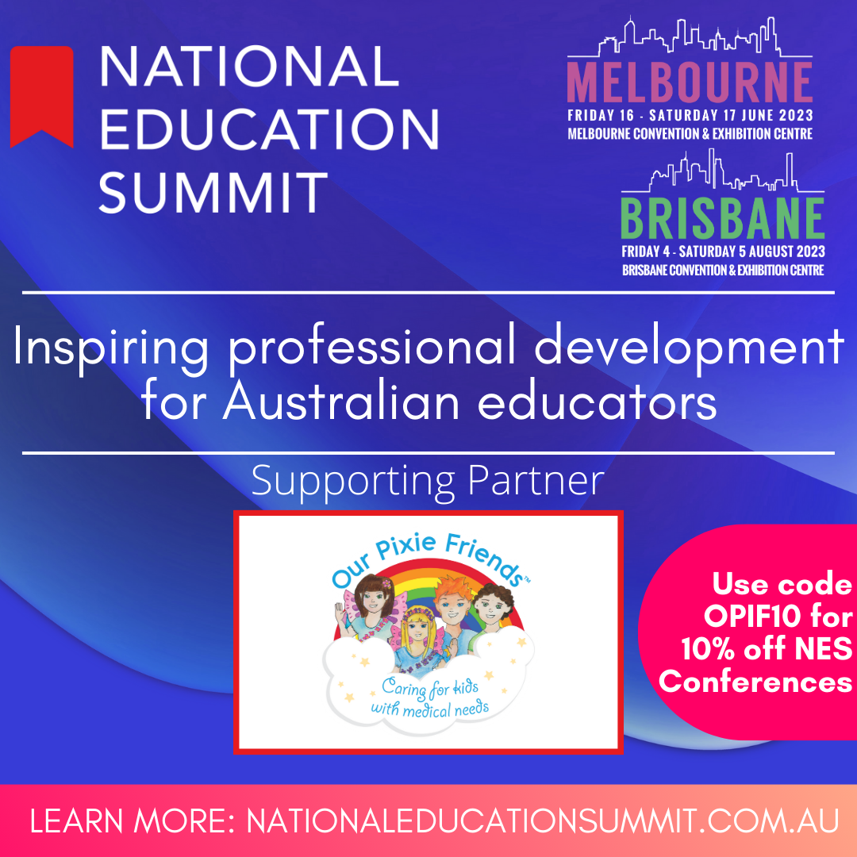

CALLING ALL EDUCATORS! SPRIZZLETASTIC NEWS!
We’re Presenting at the National Education Summit!
All Our Pixie Friends supporters can apply the discount code OPIF10 to receive 10% off the registration!

Severe Anxiety - Lived Experience

Siobhan, now 14, was diagnosed with GAD (Generalised Anxiety Disorder) and PTSD (Post Traumatic Stress Disorder) at the age of 2. Complex medical traumas have impacted her mental health and wellbeing, and her ability to function at school leading to her now being homeschooled by her mother, Fiona, an experienced primary teacher with additional qualifications in Special Education.
Hear first-hand from a student with severe anxiety about how it impacted her life at day care and school. In this session, Siobhan will share her life story of trauma and anxiety. She will share the difficulties she experienced as a student. Fiona will add to this with experience from a parent's perspective - a special education teacher who has worked closely with psychiatrists, psychologists, occupational therapists and a multitude of medical specialists for 10 years.
This session will include presentation as well as some discussion to enable teachers to walk away with added insight into students' experiences, what happens in the body and brain as a result of complex traumas and some practical knowledge of how to recognise and handle children experiencing severe anxiety.
Is it ASD, ADHD or NVLD? NVL - What?
Fiona is a primary teacher with over 30 years' experience - more than 20 years in early childhood. She has additional qualifications in Special Education and majored in Gifted Education. In the past, she presented at state and national conferences on gifted education, outlining practical strategies to cater for the range of abilities in regular classrooms.
Fiona also has extensive experience parenting one gifted child and one twice exceptional child with NVLD - Nonverbal Learning Disorder. For the past few years, Fiona has been homeschooling her daughter, a new rollercoaster ride, which has given her extensive insight into the impact of neurodiversity on everyday life and the resultant strain on a child's mental health and wellbeing.
Session Description - presentation
In the U.S. alone, there are an estimated 2.5 million children and adolescents with NVLD - Nonverbal Learning Disorder, but in Australia, it is hardly recognised. There is currently a submission to have this condition added to the Diagnostic Statistical Manual relabelled as Visual-Spatial Developmental Disorder to avoid confusion over the name, since children with NVLD are very verbal.
With strengths in verbal language, but deficits in sensory/motor skills, executive function, understanding social cues and visual-spatial skills, these children are often diagnosed as gifted in the early years, but by mid-primary, they are starting to struggle. Many are misdiagnosed as having ASD or ADHD because the conditions share some characteristics.
This session will outline the current research on NVLD, the areas of life impacted by this condition, the similarities and differences with ASD and ADHD and most importantly, some practical strategies for classroom practice which may help numerous children, especially those with neurodiversity.
Siobhan will also be conducting a book reading and a craft activity for the children during the conference.
We can’t wait to see you there!

